Contents

1. Lidar Obstacle Detection 2

2. Radar 2

2.1 Radar Principles 2

2.1.1 The Radar Sensor 2

2.1.2 Signal Properties 4

2.1.3 FMCW 6

2.1.4 FMCW Hardware and Antenna 7

2.1.5 Radar Cross Section 9

2.1.6 Radar Range Equation 10

2.1.7 Placeholder 12

2.2 Range-Doppler Estimation 12

2.2.1 Range, Velocity and Angle Resolution 12

2.2.2 Range Estimation 13

2.2.3 Doppler Estimation 14

2.2.4 Fast Fourier Transform 17

2.2.5 The 2D FFT 19

2.2.6 Placeholder 20

2.3 Clutter, CFAR, AoA 20

2.3.1 Clutter 20

2.3.2 CFAR 22

2.3.3 CA-CFAR 23

2.3.4 CFAR 2D 24

2.3.5 Angle of Arrival 25

2.4 Clustering and Tracking 27

2.4.1 Clustering 27

2.4.2 Kalman Tracking 28

2.5 Radar Target Generation and Detection 29

2.5.1 Radar Target Generation and Detection 29

2.5.2 Placeholder 33

2.6 Placeholder 33

3. Camera 33

Sensor Fusion Nanodegree

# Lidar Obstacle Detection

# Radar

## Radar Principles

### The Radar Sensor

The image below shows how radar sensors are used along with a full suite of other sensors in an autonomous vehicle:

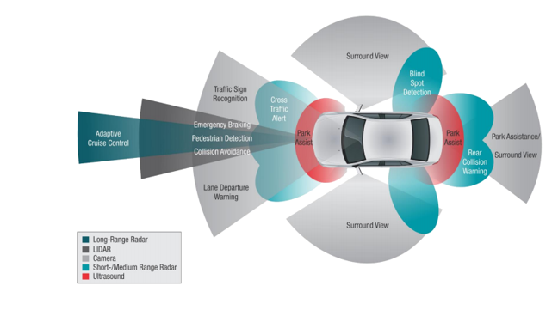

**Radar Operation**

Radar works using the transmission and detection of electromagnetic waves as seen in the following image:

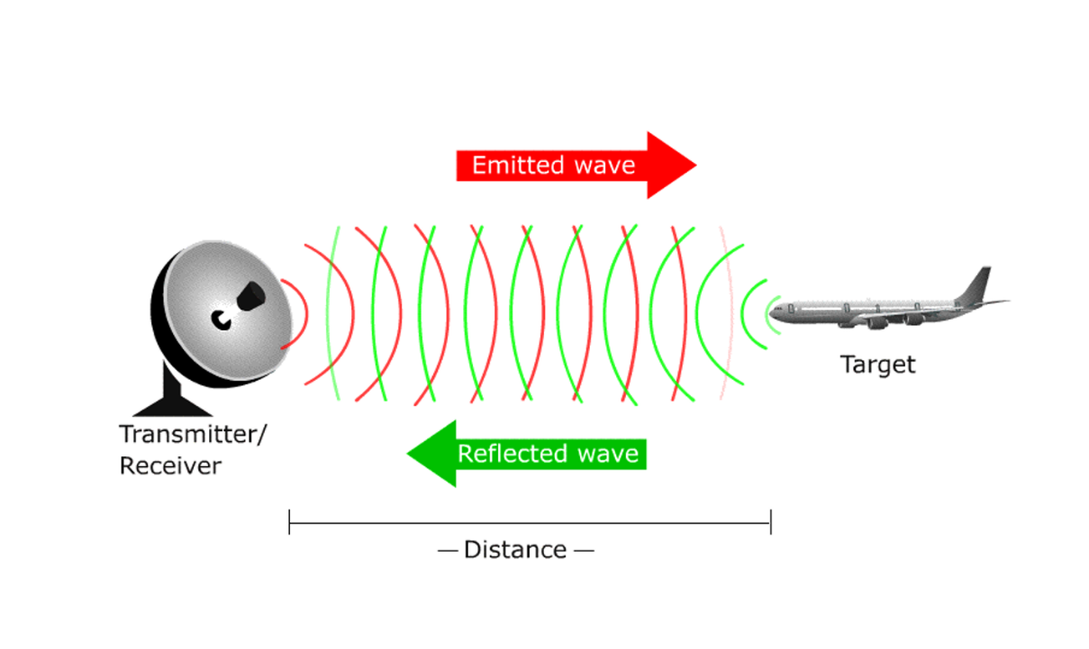

The electromagnetic waves are reflected if they meet an obstacle. If these reflected waves are received again at the place of their origin, then that means an obstacle is in the propagation direction. The frequency of electromagnetic energy used for radar is unaffected by darkness and also penetrates fog and clouds. This permits radar systems to determine the position of road targets that are invisible to the naked eye because of distance, darkness, or weather. Modern radar can extract widely more information from a target's echo signal than its range.

**Radar Construction**

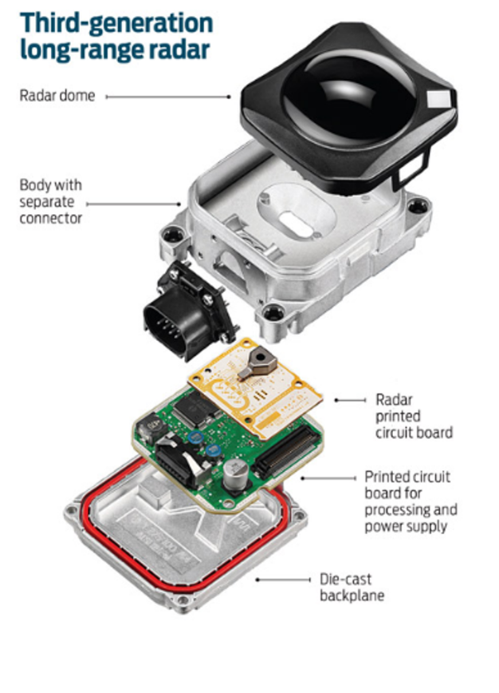

The automotive radars are small size sensors that can easily fit beneath the front grill or the bumper. As seen in the image above a radar module comprises of different parts.

*Radar Dome or Radome*: A radome is a structural, weatherproof enclosure that protects a radar antenna. The radome is constructed of material that minimally attenuates the electromagnetic signal transmitted or received by the antenna, effectively transparent to radio waves.

*Radar Printed Circuit Board*: This is analog hardware that includes the radar transceiver and antenna needed for radio wave generation.

*Printed Circuit Board and Processing*: This includes the Digital Signal Processing (DSP) unit.

**Radar vs Lidar**

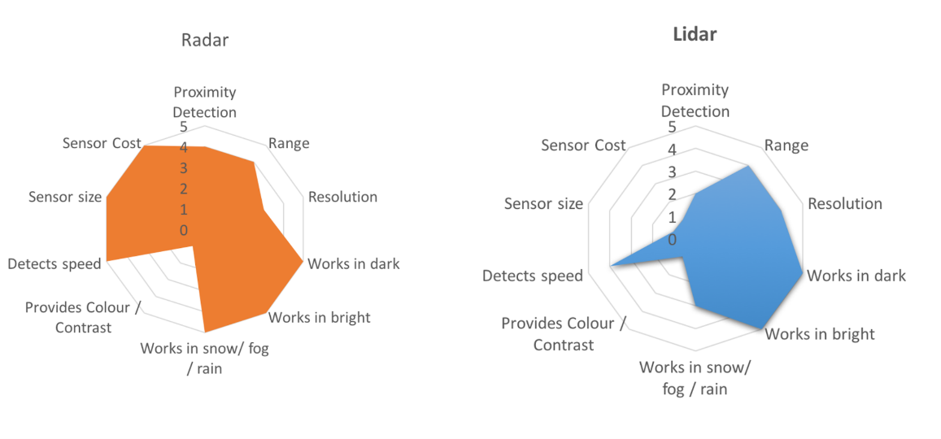

LIDAR can generate high resolution imaging based on reflection of the laser light off from the targets. But LIDARs fail in bad weather conditions as the very small wavelength doesn’t allow to work well in fog or rain. Additionally, LIDAR is an expensive sensor with costs varying from $35,000 to $100,000 as of 2019.

Radar lacks the capability to generate a high resolution image, but it has highly accurate velocity estimation based on the doppler phenomenon. Also, radar wavelength allows it to sense the targets in bad weather conditions as well. Most important is the low manufacturing cost for a Radar. A radar unit can cost as low as a few hundred dollars, allowing a car manufacturer to deploy multiple Radar sensors for 360 degree perception.

### Signal Properties

**Signal Wave Parameters**

Wavelength (λ) is the physical length from one point of a wave to the same point on the next wave, and it is calculated as

λ = $\frac{speed of light}{frequency}$

The higher the frequency the smaller the wavelength.

The *frequency* of a wave is the number of waves that pass by each second, and is measured in Hertz (Hz). The automotive radar generally operates at W band (76GHz - 81GHz). The signal at this frequency is referred to as millimeterWave since the wavelength is in mm.

The *Bandwidth* of a signal is the difference between the highest and the lowest frequency components in a continuous band of frequencies.

The *Amplitude* is the strength of the signal. Often it corresponds to the power of the RF signal/electromagnetic field defined in dB/dBm. It is relevant while configuring the output power of the radar and sensing the received signal. Higher the amplitude of the Radar signal, more is the visibility of radar. Automotive Radar can operate at max of 55 dBm output power (316 W)

**Phase of a Signal**

Phase is a particular point in time on the cycle of a waveform, measured as an angle in degrees. A complete cycle is 360°. The phase for each argument value, relative to the start of the cycle, is shown in the image below, in degrees from 0° to 360° and in radians from 0 to 2π.

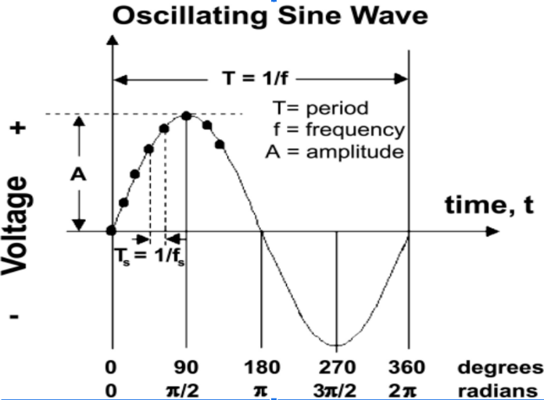

The frequency can also be defined as the first derivative of the phase with respect to the time.

$frequency= \frac{dφ}{dt}$ where $φ=phase of the signal$

The difference between the phases of two periodic signals is called the phase difference. At values of when the difference is zero, the two signals are said to be in phase, otherwise they are out of phase with each other.

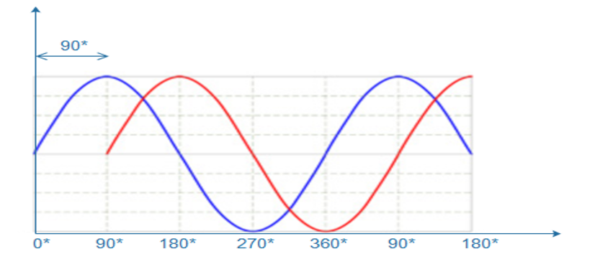

**General Equation of a Wave**

A wave travelling in space is defined by the following equation:

$y\left(t\right)=A cos⁡(2π*f_{c}*t+ φ)$

### FMCW

FMCW radar (Frequency-Modulated Continuous Wave radar) is a special type of radar sensor which radiates continuous transmission power. FMCW radar’s ability to measure very small ranges to the target as well as its ability to measure simultaneously the target range and its relative velocity makes it the first choice type of radar for automotive applications.

**FMCW Chirps**

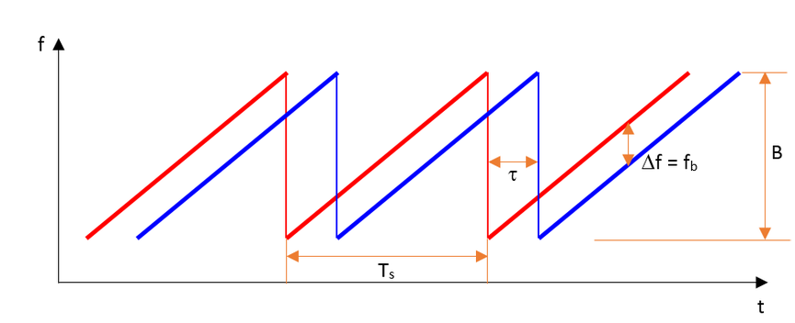

A Frequency Modulated Continous Wave (FMCW) is a signal in which the frequency increases/decreases with time. They are also referred to as upramps and downramps. The two most common waveform pattern used for FMCW radars are sawtooth and triangular. The sawtooth waveform generally uses just the upramps, whereas the triangular waveform uses both upramps and downramps.

Each chirp is defined by its slope. The slope is given by its chirp frequency bandwidth $B$ or $B_{sweep}$ (y-axis) and its chirp time $T_{s}$ (x-axis). Hence,

$Slope= \frac{B}{T_{s}}$

The range resolution requirement decides the $B$, whereas the maximum velocity capability of a radar is determined by the chirp time $T_{s}$.

One chirp sequence or segment comprises of multiple chirps. Each chirp is sampled multiple times to give multiple range measurements and radar transmits in order to measure doppler velocity accurately.

### FMCW Hardware and Antenna

**FMCW Hardware Overview**

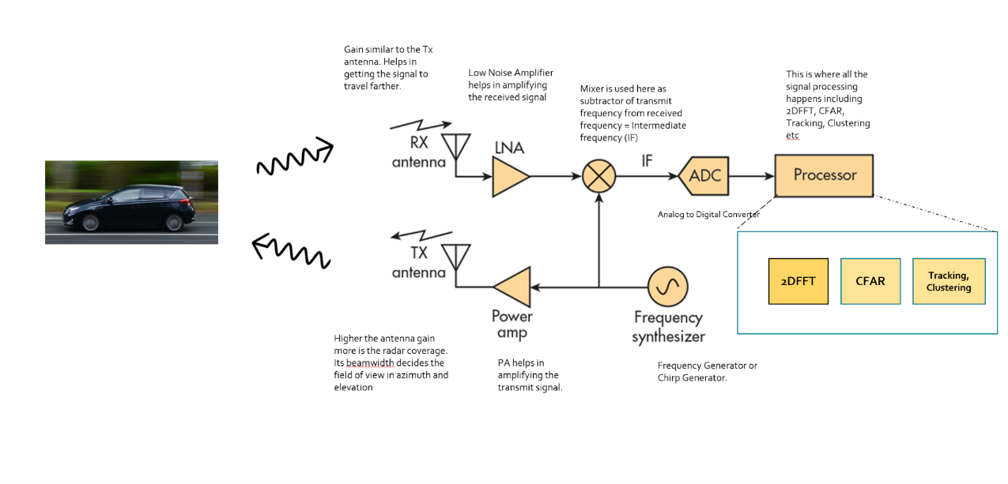

*Frequency Synthesizer*: The frequency synthesizer is the component that generates the frequency to bring the chirp frequency all the way to 77GHz in case of automotive radar.

*Power Amp*: The power amp amplifies the signal so the signal can reach long distance. Since the signal attenuates as it radiates, it needs higher power (amplitude) to reach targets at greater distances.

*Antenna*: The antenna converts the electrical energy into electromagnetic waves which radiate through the air, hit the target, and get reflected back toward the radar receiver antenna. The Antenna also increases the strength of the signal by focusing the energy in the desired direction. Additionally, the antenna pattern determines the field of view for the radar.

*Mixer*: In FMCW radar, the mixer multiplies the return signal with the sweeping signal generated by the frequency synthesizer. The operation works as frequency subtraction to give the frequency delta - also known as frequency shift or Intermediate frequency (IF). IF = Synthesizer Frequency - Return Signal Frequency.

*Processor*: The processor is the processing unit where all the Digital Signal processing, Detection, Tracking, Clustering, and other algorithms take place. This unit could be a microcontroller or even an FPGA.

**Antenna Details**

As defined in the FMCW Hardware definitions, the antenna is a transducer that converts the electrical energy into electromagnetic waves. In the case of radar, these waves travel through the air and hit the target. Depending on the surface type and shape of the target, the waves get partially reflected back in the direction of the radar. The receiver antenna at the radar amplifies the received signal further and sends it to the receiver chain for further processing.

**The Antenna Pattern**

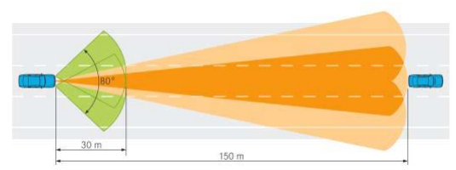

The *antenna pattern* is the geometric pattern of the strengths of the relative field emitted by the antenna. The *beamwidth* of the antenna determines the field of view for the radar sensor. If the requirement for the radar is to just sense the targets in its own lane then the beamwidth needs to be small enough to cover the complete lane up to desired range. If the beamwidth is wider than the lane width, it will sense the targets in the other lanes as well.

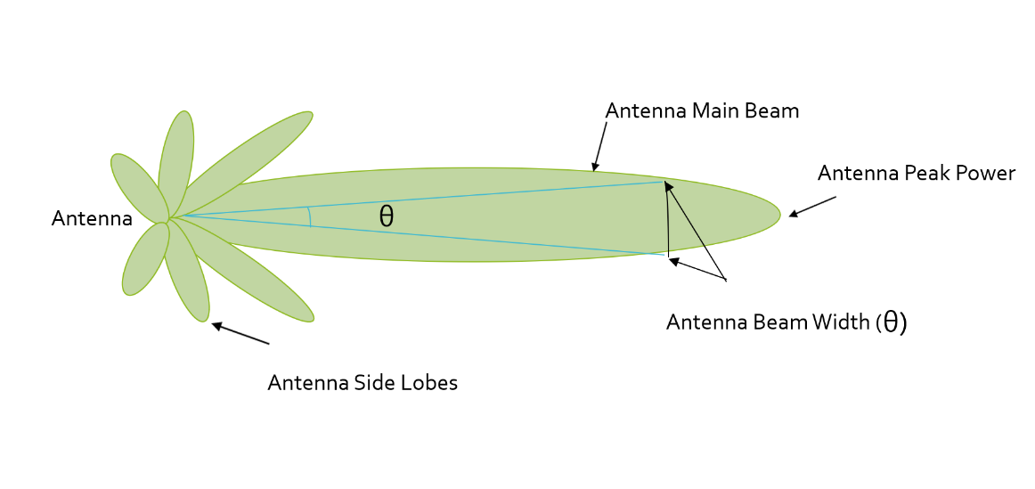

Antenna radiation not only comprises of the main beam but the sidelobes as well. Antenna sidelobes are critical because they can generate false alarms and pick interference from undesired direction. As seen in the pattern, the sidelobes of the antenna point in different directions and can sense targets that are not in the main beam. To avoid sidelobe detections it is critical to suppress the sidelobe levels to more than 30dB from the peak of the main beam.

**Antenna Types**

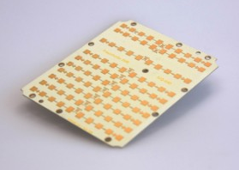

There are many types of antenna (dipole, patch, horn) that can be used at 77GHz, but the most commonly used antenna type in automotive radar is the patch antenna . The low cost, easy fabrication, and low profile of Patch Array Antennas makes them an ideal choice for automotive radar applications.

### Radar Cross Section

**Radar Cross Section Overview**

The size and ability of a target to reflect radar energy is defined by a single term, σ, known as the radar cross-section, which has units of $m^{2}.$ This unit shows that the radar cross section is an area. The target radar cross sectional area depends on:

* The target’s physical geometry and exterior features:  
  Smooth edges or surface would scatter the waves in all directions, hence lower RCS. Whereas, sharp corners will focus the return signal back in the direction of the source leading to higher RCS. (Image below for different target geometries)
* The direction of the illuminating radar
* The radar transmitter’s frequency
* The material used in the cars, trucks, bicycles, and even in some cases, the clothing material for pedestrians.

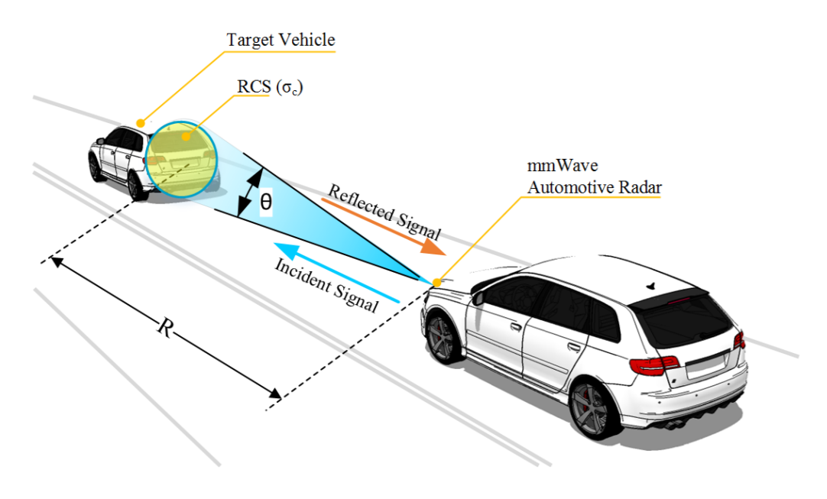

If absolutely all of the incident radar energy on the target were reflected equally in all directions, then the radar cross section would be equal to the target's cross-sectional area as seen by the transmitter. In practice, some energy is absorbed and the reflected energy is not distributed equally in all directions. Therefore, the radar cross-section is quite difficult to estimate and is normally determined by measurement.

Returns from different target geometries:

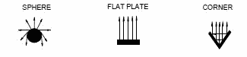

**RCS Units**

This RCS can also be defined using a logarithmic value (dB), since it increases the return signal strength. The formula for converting from RCS to dB is given by:

${RCS}_{dB}=10*\log\left({RCS}_{m^{2}}\right)$

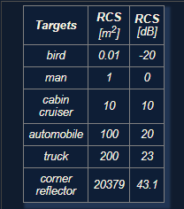

### Radar Range Equation

**Range Equation Overview**

Using the Radar Range equation we can design the radar transmitter, receiver, and antenna to have the desired power, gain and noise performance to meet the range requirements.

A long range radar designed to cover 300m range and detect a target with smaller cross section would need higher transmit power and more antenna gain as compared to a short range radar designed to cover just 50m for similar target. A target with higher cross section can be detected at a longer range as compared to a target with smaller cross section.

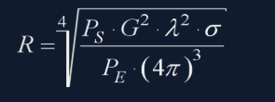

* $R$- Maximum Range a radar can detect targets.
* $P_{s}$- Transmitted Power from Radar ($dBm$)
* $G$- Gain of the Transmit/Receive Antenna ($dBi$)
* $λ$- Wavelength of the signal ($m$)
* $σ$- radar cross section ($m^{2})$
* $P_{E}$- Minimum received power radar can detect

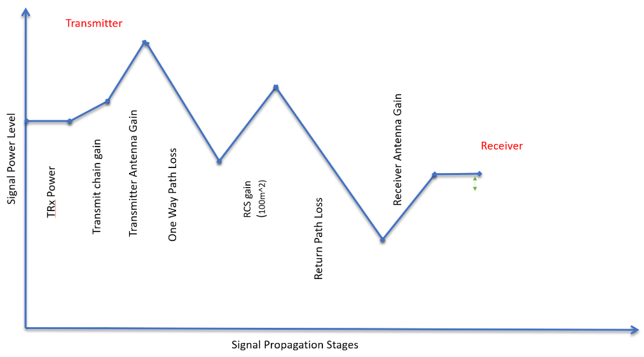

The image above shows the variation in the signal strength level as it travels through transmitter, over the air and at the receiver

The image above shows the variation in the signal strength level :

* The transmitter power
* Power Amplifiers further increase the signal strength - Transmit chain gain
* Signal is further amplified using an antenna
* One Way Path Loss represents the loss in the signal strength as it travels towards the target
* On getting reflected from the target the signal gets amplified based on the RCS of the target
* After RCS gain the signal travel back towards the radar and has similar loss in strength as going forward
* The receiver antenna amplifies the return signal before sending it to the processing unit

**Radar Detection**

Below is an illustration showing the output of a radar's range detection. The peaks correspond to the strength of the return signal from targets and the frequency relates to the range. Relationship between frequency and range will be discussed in next lesson.

A radar cannot detect a signal that is below the noise level. The noise level is determined by the thermal noise generated by the receiver. To successfully detect a target, the return signal strength needs to be larger than the noise level. This is defined by a property called signal to noise ratio, or SNR.

SNR is a quantitative measure of a signal strength as compared to the level of noise. If the SNR is too low it becomes difficult for a radar to distinguish the signal from noise. Hence, higher SNR is desirable for successful detection of the target. Generally, a 7-13 dB SNR ensures successful detection in a road scenario.

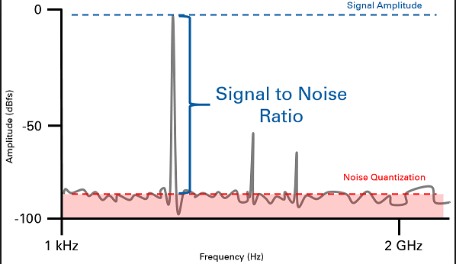

The image above shows the logarithmic value of SNR = power level (in dBm) - noise level (dBm). The plot shows the output of Range FFT. In general, the higher the SNR value, the greater are the chances of successful Radar detection.

### Placeholder

## Range-Doppler Estimation

### Range, Velocity and Angle Resolution

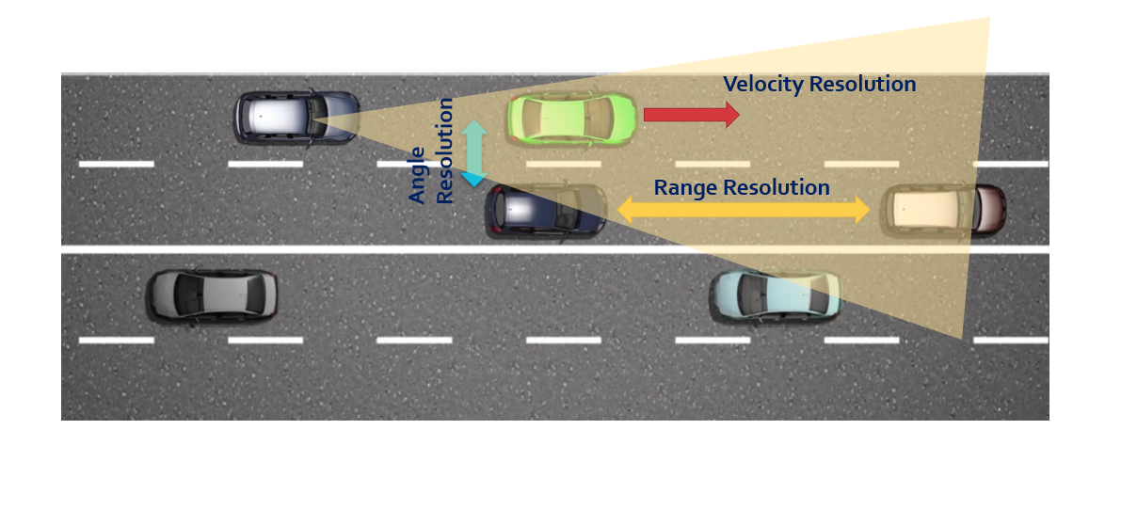

**Range Resolution**: It is the capability of the radar to distinguish between two targets that are very close to each other in range. If a radar has range resolution of 4 meters then it cannot separate on range basis a pedestrian standing 1 m away from the car.

The range resolution is solely dependent on the bandwidth of the chirp $B_{sweep}$:

$d_{res}= \frac{c}{2B_{sweep}}$

**Velocity Resolution**: If two targets have the same range they can still be resolved if they are traveling at different velocities. The velocity resolution is dependent on the number of chirps. As discussed for our case we selected to send 128 chirps. A higher number of chirps increases the velocity resolution, but it also takes longer to process the signal.

**Angle Resolution**: Radar is capable of separating two targets spatially. If two targets are at similar range travelling at same velocities, then they can still be resolved based on their angle in radar coordinate system. Angle resolution depends on different parameters depending on the angle estimation technique used.

### Range Estimation

**Range Estimation Overview**

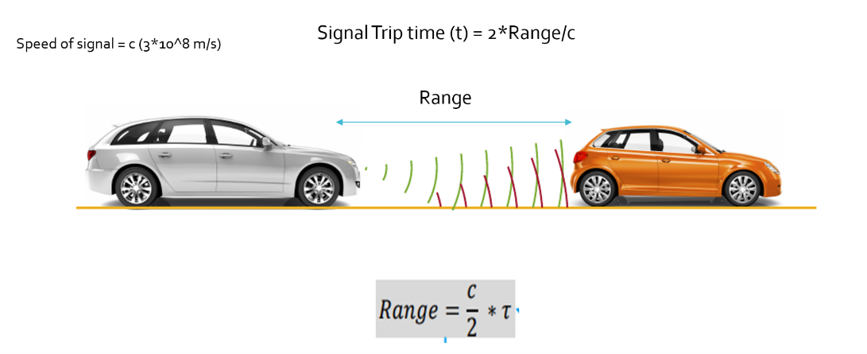

Radar determines the range of the target by measuring the trip time of the electromagnetic signal it radiates. It is known that EM wave travels at a known speed (300,000,000 m/s), so to determine the range the radar needs to calculate the trip time by measuring the shift in the frequency.

**Range Estimation Equation**

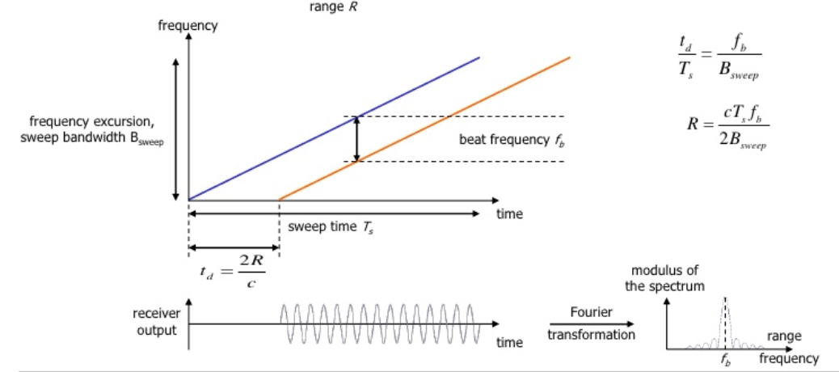

The FMCW waveform has the characteristic that the frequency varies linearly with time. If radar can determine the delta between the received frequency and hardware’s continuously ramping frequency then it can calculate the trip time and hence the range. We further divide Range estimate by 2, since the frequency delta corresponds to two way trip.

It is important to understand that if a target is stationary then a transmitted frequency and received frequency are the same. But, the ramping frequency within the hardware is continuously changing with time. So, when we take the delta (beat frequency) between the received and ramping frequency we get the trip time.

$R= \frac{cT_{s}f_{b}}{2B_{sweep}}$

Here, $f_{b}$ is the beat frequency, which is measured by the radar by subtracting the received frequency from the hardware’s ramping frequency:

$f_{b}= f_{ramping}- f_{received}$

As seen in the equation, the range calculation requires chirp time $T_{s}$ and chirp Bandwidth $B_{sweep}$. Those values are determined as we define the configuration of the radar based on its range resolution and trip time for Radar’s maximum range.

**System Level Range Calculation**

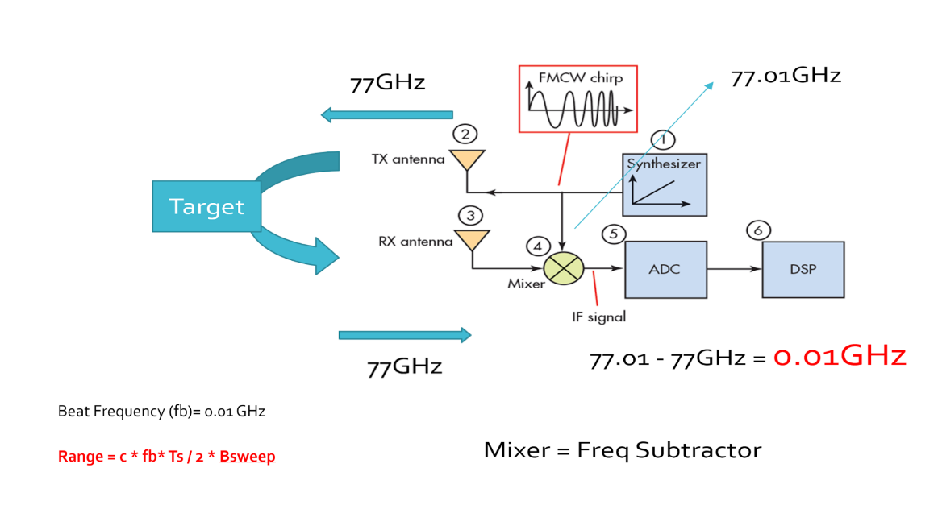

As seen in the image above, the Synthesizer generates FMCW chirp for a given $B_{sweep}$ and $T_{s}$. Let’s say the signal gets transmitted at 77GHz and it returns to the radar after hitting the target in a certain time duration. The radar receiver captures the signal, processes (subtraction) and measures the frequency delta between received signal and linearly ramping signal. This delta in frequency is called as beat frequency and it is proportional to the trip time. So based on the equation above, the radar calculates the range.

### Doppler Estimation

**Doppler Estimation Overview**

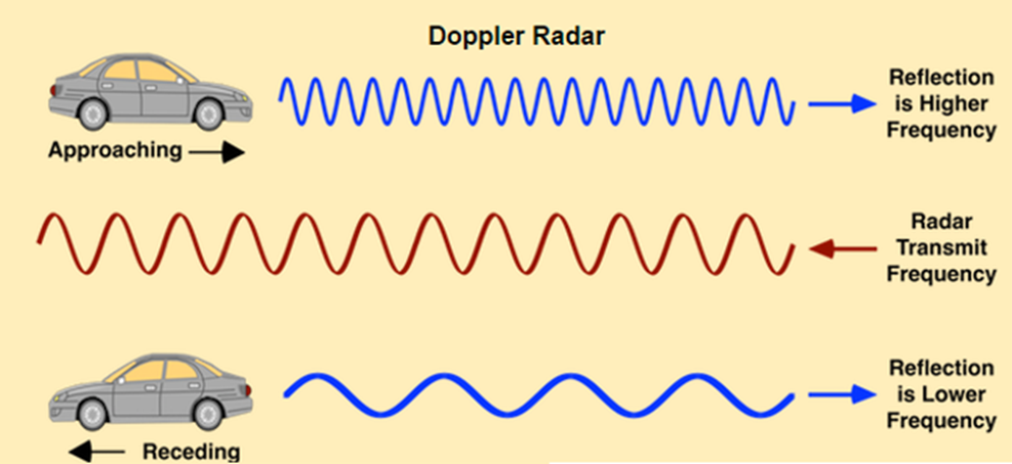

The velocity estimation for radar is based on an age old phenomenon called the doppler effect. As per doppler theory an approaching target will shift an emitted and reflected frequency higher, whereas a receding target will shift the both frequencies to be lower than the transmitted frequency.

**FMCW Doppler Measurements**

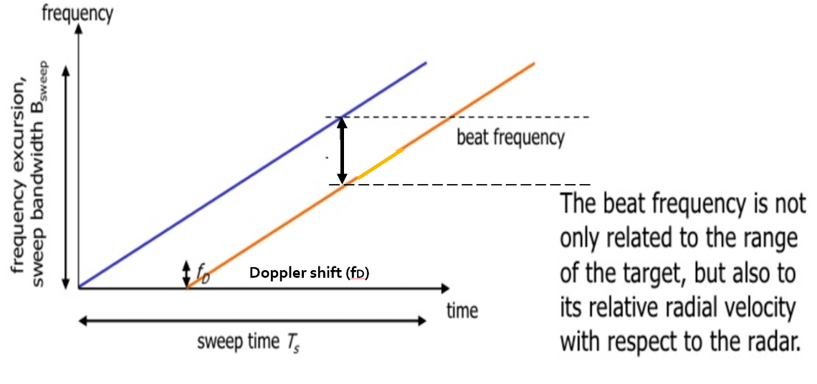

As discussed above, there will be a shift in the received signal frequency due to the doppler effect of the target’s velocity. The doppler shift is directly proportional to the velocity of the target as shown below:

$f_{D}= \frac{2v_{r}}{λ}$

$f_{D}$: shift in the transmitted frequency due to the doppler

$v_{r}$: relative velocity of the target

$λ$: wavelength of the signal

By measuring the shift in the frequency due to doppler, radar can determine the velocity. The receding target will have a negative velocity due to the frequency dropping lower, whereas the approaching target will have positive velocity as the frequency shifts higher.

The beat frequency comprises of both frequency components: $f_{r}$ (frequency delta due to range) and $f_{d}$ (frequency shift due to velocity). Although, in the case of automotive radar the $f_{d}$ is very small in comparison to the $f_{r}$. Hence, the doppler velocity is calculated by measuring the rate of change of phase across multiple chirps.

The following equation shows the relationship between the rate of change of the phase $φ$, and the frequency:

$$\frac{dφ}{dt}= frequency$$

**Doppler Phase Shift**

Keeping that in consideration, we calculate the doppler frequency by measuring the rate of change of phase. The phase change occurs due to small displacement of a moving target for every chirp duration. Since, each chirp duration is generally in microseconds, it results in small displacement in mm (millimeters). These small displacements for every chirp leads to change in phase. Using this rate of change of phase we can determine the doppler frequency.

If the path between a target and the radar is changed by an amount Δx, the phase of the wave received by radar is shifted by

$Δφ= \frac{Δx}{λ} \left(λ=2π or 360˚\right)$ $$Δφ=f* \frac{Δx}{c} (λ= f/c)$$

where λ and f are, respectively, the wavelength and frequency of the signal and c is the speed of propagation. The resulting change in observed frequency is

$Δf= \frac{Δφ}{Δt}$

where $Δt$ is the time taken for the observation of the phase change.

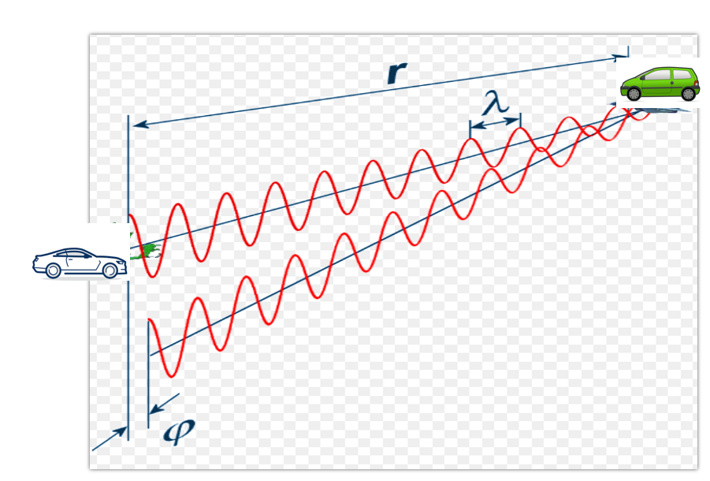

### Fast Fourier Transform

**FFT Overview**

So far we discussed the theory of range and doppler estimation along with the equations to calculate them. But, for a radar to efficiently process these measurements digitally, the signal needs to be converted from analog to digital domain and further from time domain to frequency domain.

ADC (Analog Digital Converter) converts the analog signal into digital. But, post ADC the Fast Fourier Transform is used to convert the signal from time domain to frequency domain. Conversion to frequency domain is important to do the spectral analysis of the signal and determine the shifts in frequency due to range and doppler.

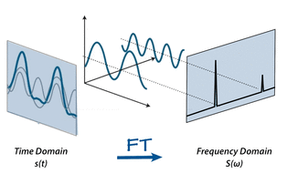

The traveling signal is in time domain. Time domain signal comprises of multiple frequency components as shown in the image above. In order to separate out all frequency components the FFT technique is used. FFT gives the frequency response of the return signal with each peak in frequency spectrum representing the detected target’s characteristics.

**FFT and FMCW**

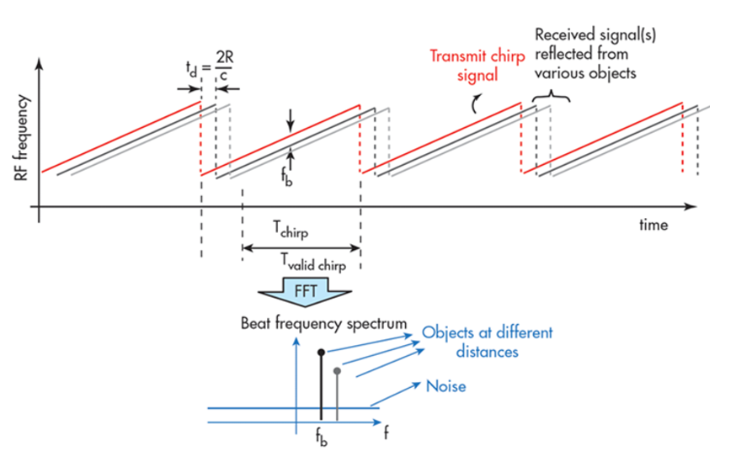

As seen in the image below, the Range FFTs are run for every sample on each chirp. Since each chirp is sampled N times, it will generate a range FFT block of N * (Number of chirps). These FFT blocks are also called FFT bins.

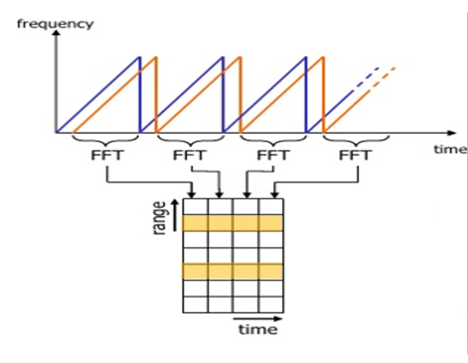

Range FFT

Each chirp is sampled N times, and for each sample it produces a range bin. The process is repeated for every single chirp. Hence creating a FFT block of N*(Number of chirps).

Each bin in every column of block represents increasing range value, so that the end of last bin represents the maximum range of a radar.

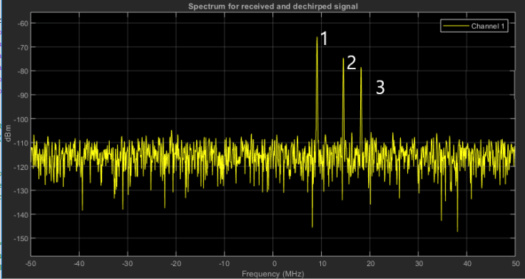

Output of Range FFT in MATLAB. X-axis = Beat Frequency, Y-axis = Signal power in dBm

Above is the output of the 1st stage FFT (i.e Range FFT). The three peaks in the frequency domain corresponds to the beat frequencies of three different cars located at 150, 240 and 300 m range from the ego vehicle.

### The 2D FFT

Once the range bins are determined by running range FFT across all the chirps, a second FFT is implemented along the second dimension to determine the doppler frequency shift. As discussed, the doppler is estimated by processing the rate of change of phase across multiple chirps. Hence, the doppler FFT is implemented after all the chirps in the segment are sent and range FFTs are run on them.

The output of the first FFT gives the beat frequency, amplitude, and phase for each target. This phase varies as we move from one chirp to another (one bin to another on each row) due to the target’s small displacements. Once the second FFT is implemented it determines the rate of change of phase, which is nothing but the doppler frequency shift.

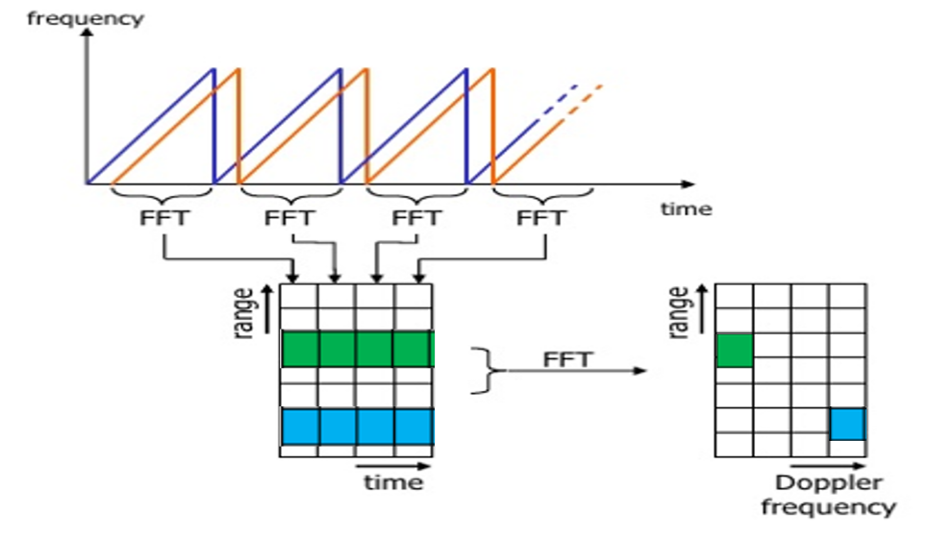

After running 2nd FFT across the rows of FFT block we get the doppler FFT. The complete implementation is called 2D FFT.

After 2D FFT each bin in every column of block represents increasing range value and each bin in the row corresponds to a velocity value. The output of Range Doppler response represents an image with Range on one axis and Doppler on the other. This image is called as Range Doppler Map (RDM). These maps are often used as user interface to understand the perception of the targets.

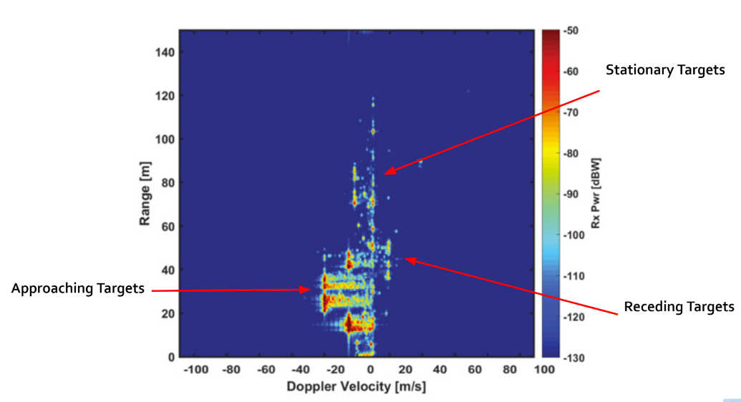

### Placeholder

* + 1. ff

## Clutter, CFAR, AoA

### Clutter

Radar not only receives the reflected signals from the objects of interest, but also from the environment and unwanted objects. The backscatter from these unwanted sources is called clutter.

These unwanted signals are generally produced by reflections from the ground, sea, buildings, trees, rain, fog etc. The magnitude of the clutter signal depends upon:

* The nature of the surface - ground, water, snow (e.g deserts have low reflectivity, whereas the frozen snow has high reflectivity)
* Smoothness of the surface
* Grazing angle - Angle the radar beam makes with the surface
* Radar Frequency

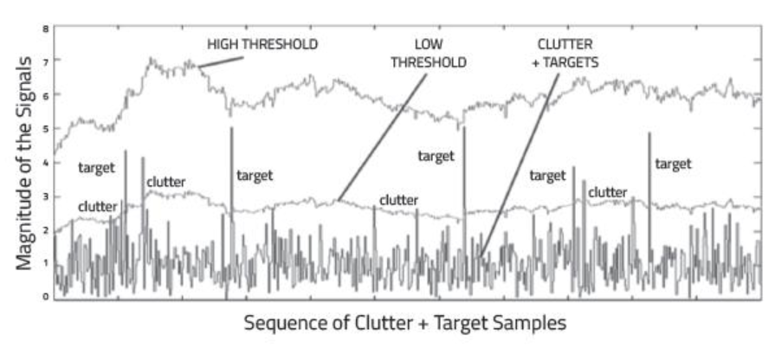

Return Signal from multiple targets along with some from the clutter

**Clutter Thresholding**

It is important to filter out clutter for successful detection of targets. This is critical in a driving scenario to avoid the car from suddenly braking in the absence of valid targets. This sudden braking happens when the radar detects reflections that are generated from the clutter.

One technique to remove clutter is to remove the signals having 0 doppler velocity. Since, the clutter in the driving scenario are often created by the stationary targets, the 0 doppler filtering can help get rid of them.

The downside of 0 doppler filtering is that the radar would not be able to detect the stationary targets in its path. This would lead to detection failures.

Another technique is to use fixed clutter thresholding. With fixed thresholding, signal below the threshold value is rejected. With this method, if the detection threshold is set too high, there will be very few false alarms, but it will also mask the valid targets. If the threshold is set too low, then it would lead to too many false alarms. In other words, the false alarm rate would be too high.

The false alarm rate is the rate of erroneous radar detections by noise or other interfering signals. It is a measure of the presence of detected radar targets when there is no valid target present.

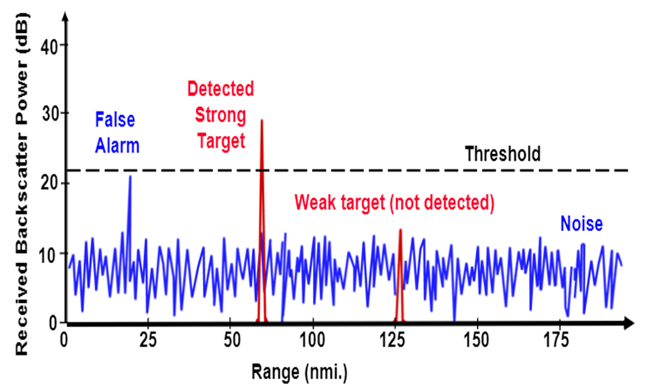

Fixed Threshold leading to False Alarms and missed detections of weak target

**Dynamic Thresholding**

Another approach to clutter thresholding is to use dynamic thresholding. Dynamic thresholding involves varying the threshold level to reduce the false alarm rate.

CFAR (Constant False Alarm Rate) is a dynamic thresholding technique. With this technique, the noise at every or group of range/doppler bins is monitored and the signal is compared to the local noise level. This comparison is used to create a threshold which holds the false alarm rate constant.

### CFAR

CFAR

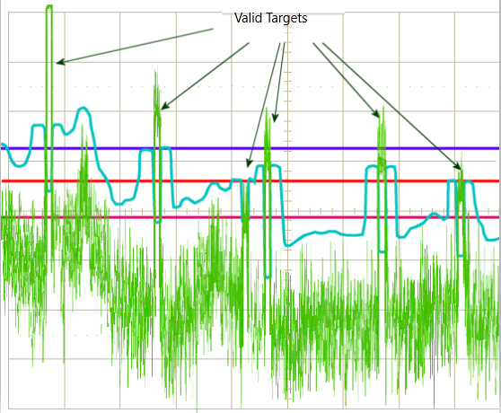

CA-CFAR and OS-CFAR

The false alarm issue can be resolved by implementing the constant false alarm rate. CFAR varies the detection threshold based on the vehicle surroundings. The CFAR technique estimates the level of interference in radar range and doppler cells “Training Cells” on either or both the side of the “Cell Under Test”. The estimate is then used to decide if the target is in the Cell Under Test (CUT).

The process loops across all the range cells and decides the presence of target based on the noise estimate. The basis of the process is that when noise is present, the cells around the cell of interest will contain a good estimate of the noise, i.e. it assumes that the noise or interference is spatially or temporarily homogeneous. Theoretically it will produce a constant false alarm rate, which is independent of the noise or clutter level.

There are multiple categories of CFAR:

* Cell Averaging CFAR (CA-CFAR)
* Ordered Statistics CFAR (OS CFAR)
* Maximum Minimum Statistic (MAMIS CFAR)
* And, multiple variants of CA-CFAR.

Here, we will be covering the basic CA-CFAR.

### CA-CFAR

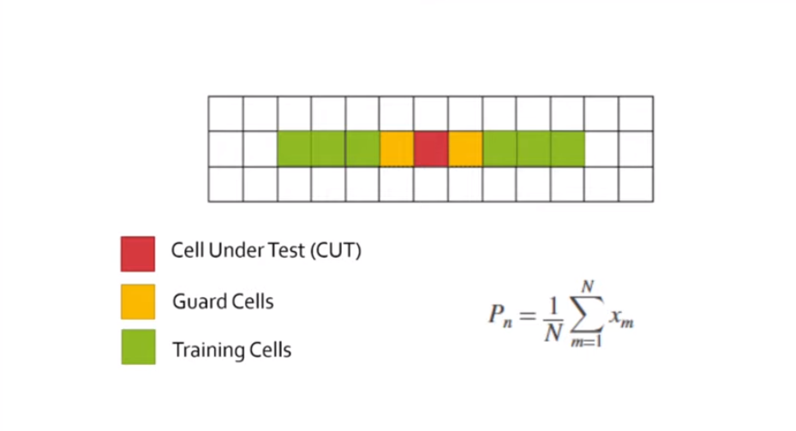

CA-CFAR Training Cells : 3 Guard Cell : 1

CA-CFAR is the most commonly used CFAR detection technique. As seen in the previous lesson, the FFT blocks are generated on implementing range and doppler FFTs across the number of chirps. The CFAR process includes the sliding of a window across the cells in FFT blocks. Each window consists of the following cells.

**Cell Under Test** : The cell that is tested to detect the presence of the target by comparing the signal level against the noise estimate (threshold).

**Training Cells** : The level of noise is measured over the Training Cells. The Training Cells can be divided into two regions, the cells lagging the CUT, called lagging Training Cells and the cells leading the CUT, called Leading Training Cells. The noise is estimated by averaging the noise under the training cells. In some cases either leading or lagging cell average is taken, while in the other the leading and lagging cell average is combined and the higher of two is considered for noise level estimate.The number of training cells should be decided based on the environment. If a dense traffic scenario then the fewer training cells should be used, as closely spaced targets can impact the noise estimate.

**Guard Cells** : The cells just next to CUT are assigned as Guard Cells. The purpose of the Guard Cells is to avoid the target signal from leaking into the training cells that could adversely affect the noise estimate. The number of guard cells should be decided based on the leakage of the target signal out of the cell under test. If target reflections are strong they often get into surrounding bins.

**Threshold Factor (Offset)** : Use an offset value to scale the noise threshold. If the signal strength is defined in logarithmic form then add this offset value to the average noise estimate, else multiply it.

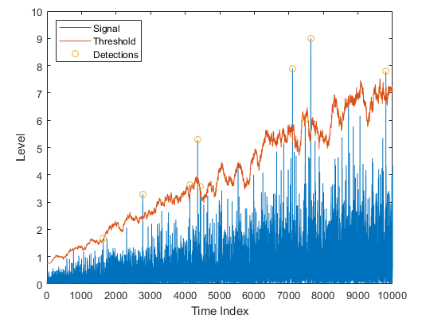

### CFAR 2D

The 2D CFAR is similar to 1D CFAR, but is implemented in both dimensions of the range doppler block. The 2D CA-CFAR implementation involves the training cells occupying the cells surrounding the cell under test with a guard grid in between to prevent the impact of a target signal on the noise estimate.

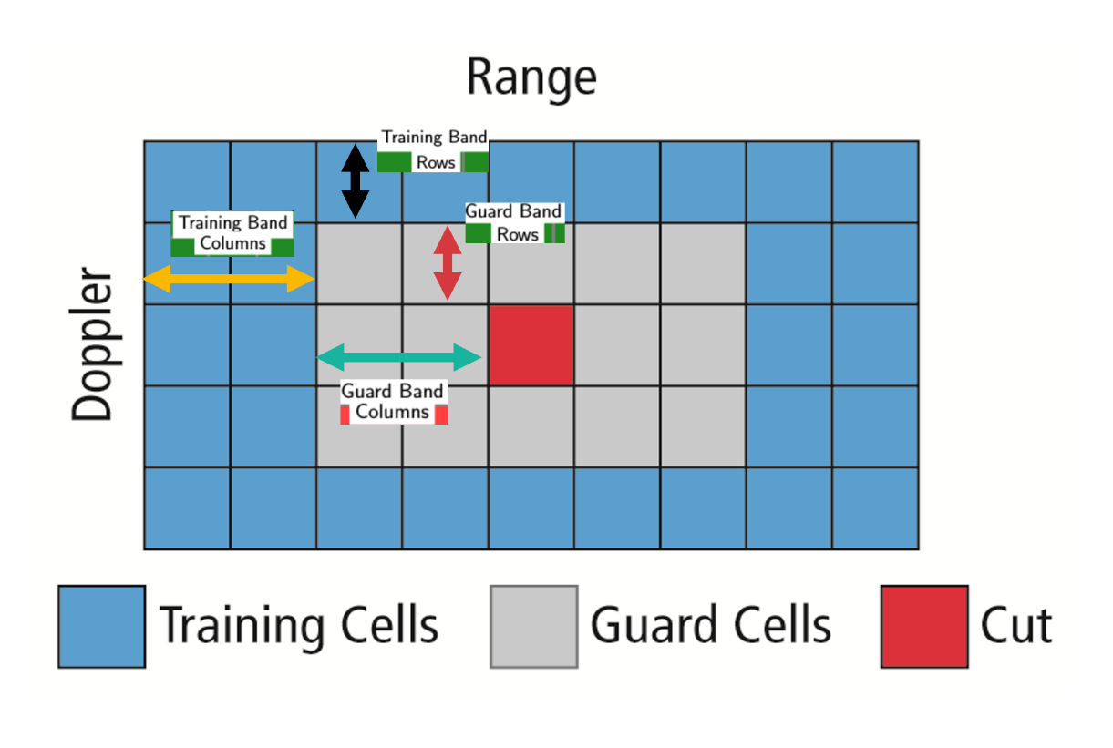

### Angle of Arrival

A phased array antenna is an antenna array that steers the beam electronically in the desired direction. The array steers the beam if each antenna element in an array is excited by the signal with certain phase values. This phenomenon is referred to as beam scanning.

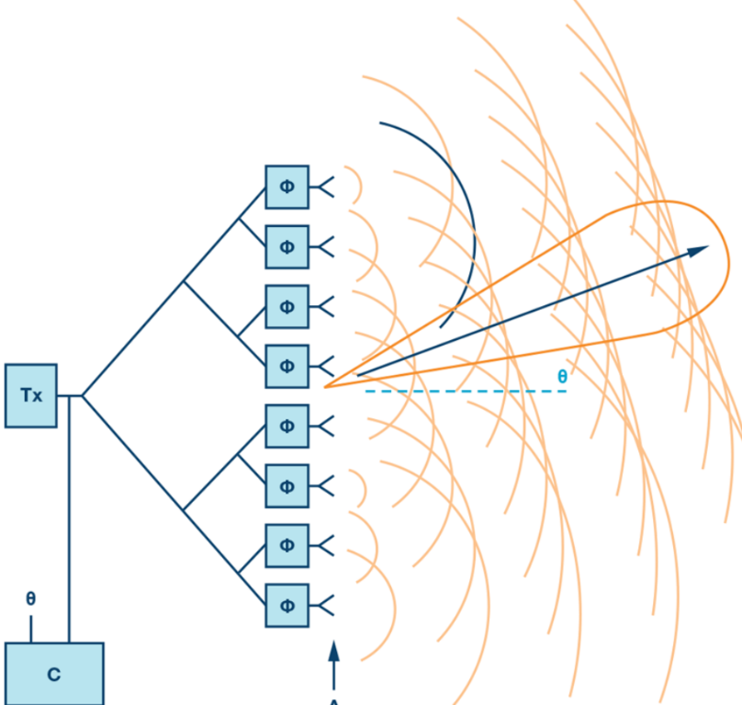

Beam Steering Design.

Here the Φ represents the phase shifters. Phase shifters are the electronic components that changes the phase to make the beam steer in a desired direction.

For antenna beam to steer in a desired direction, the phase shifters are programmed to have constant phase increments. If an antenna comprises of six radiating elements and the phase delta required to steer a beam in a given direction is 15 degrees, then the following would be the phase value on each element [0,15,30,45,60,75] degrees. The increment phase shift along with the spacing between antenna elements (d) determines the steering angle of an antenna using the following equation

$Φ=360*d*sin⁡(Θ)/λ$

* $Φ$ = incremental phase shift
* $d$ = spacing between antenna elements
* $Θ$ = steering direction from normal of the antenna surface
* $λ$ = wavelength of the signal

As the radar scan the surroundings by steering the beam at the programmed angles, it can sense the angle of the return signal. This helps Radar create a spatial perception of the environment.

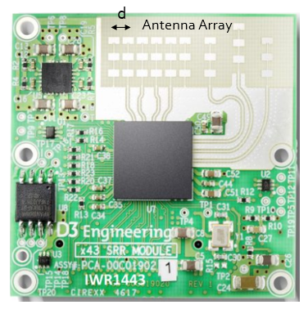

As the radar scans the surroundings by steering the beam at the programmed angles, it measures the SNR of reflected signals from targets located at different angles spatially. This helps in creating an angle of arrival vs SNR grid for radar’s spatial perception.

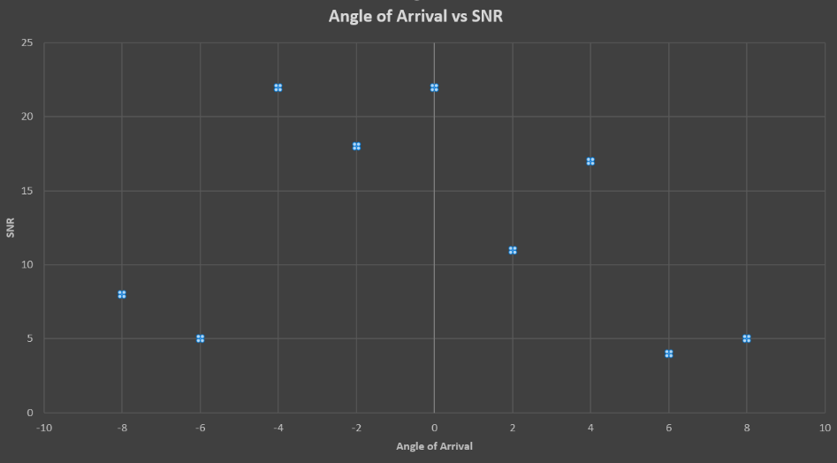

* + 1. Placeholder

## Clustering and Tracking

### Clustering

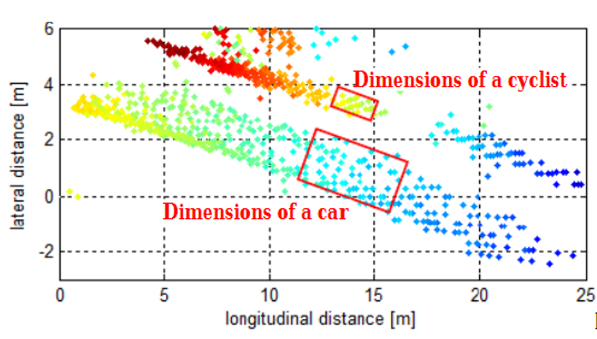

Clustering of a car and bicycle

For enhanced perception in autonomous driving, there is a need to track multiple targets separately. The object tracking is computationally expensive and tracking multiple targets simultaneously requires lots of processing power and memory.

Due to the advancements in radar technology and increasing sensing resolutions, a radar can generate detections from plentitude of scattering points on the target. If a tracker is assigned to every detection from the same target, then it can overburden the processing unit. Hence, it is important to cluster the detections from every target and assign a single track for each.

Here we will discuss the basic clustering algorithm based on the euclidean distance. The algorithm here groups the detection points based on their proximity measured by the euclidean distance between those points.

All the detection points that are within the size of the target are considered as one cluster, merged into a centroid position. Each cluster is now assigned a new range and velocity, which is the mean of measured range and velocity of all the detection points that form the cluster.

This allows valid tracking for each target.

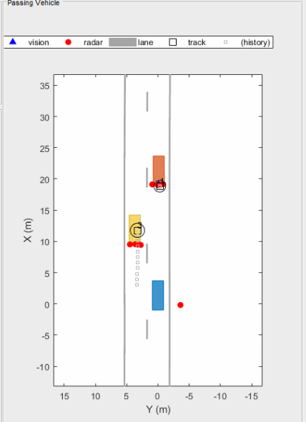

Above is an illustration of the clustering scenario. In the image the blue car is an ego vehicle (vehicle with sensor) and the detections are generated from the orange and yellow vehicles. Using clustering algorithm all the detections associated with the single target are merged into one point. This helps in the detection and assigning the tracks to a target.

### Kalman Tracking

**MATLAB Sensor Fusion**

Sensor fusion and control algorithms for automated driving systems require rigorous testing. Vehicle-based testing is not only time consuming to set up, but also difficult to reproduce. Automated Driving System Toolbox provides functionality to define road networks, actors, vehicles, and traffic scenarios, as well as statistical models for simulating synthetic radar and camera sensor detection. This example shows how to generate a scenario, simulate sensor detections, and use sensor fusion to track simulated vehicles. The main benefit of using scenario generation and sensor simulation over sensor recording is the ability to create rare and potentially dangerous events and test the vehicle algorithms with them.

* + 1. Placeholder

## Radar Target Generation and Detection

### Radar Target Generation and Detection

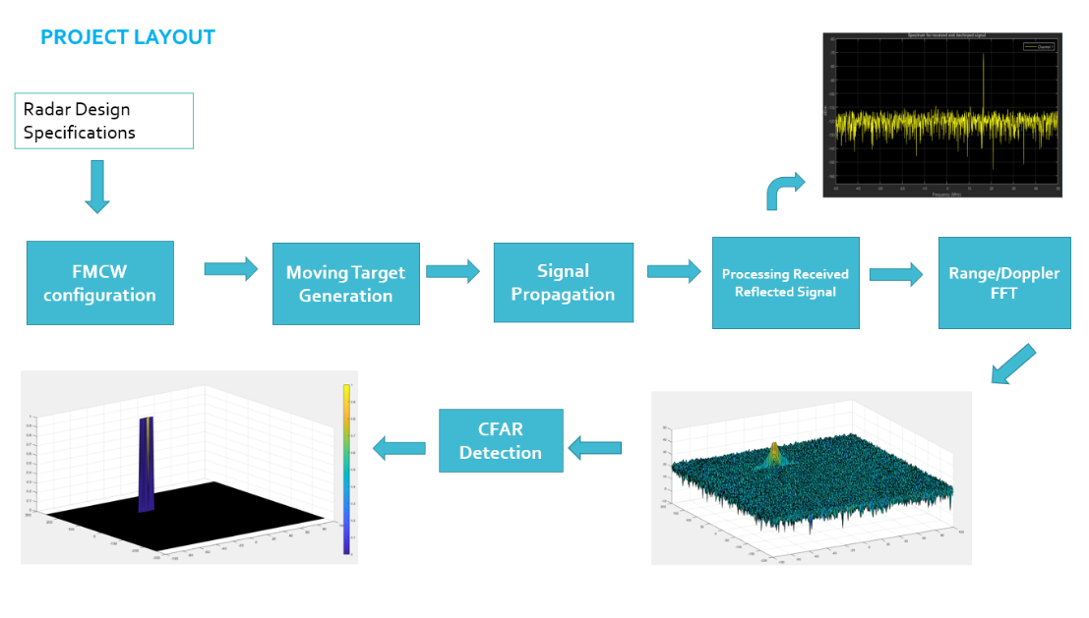

* Configure the FMCW waveform based on the system requirements.
* Define the range and velocity of target and simulate its displacement.
* For the same simulation loop process the transmit and receive signal to determine the beat signal
* Perform Range FFT on the received signal to determine the Range
* Towards the end, perform the CFAR processing on the output of 2nd FFT to display the target.

**Radar System Requirements**

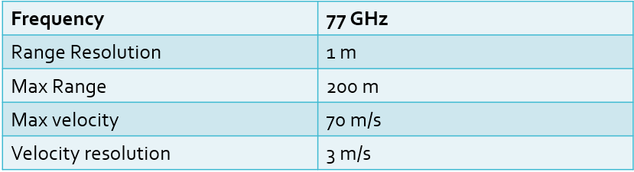

System Requirements defines the design of a Radar. The sensor fusion design for different driving scenarios requires different system configurations from a Radar. In this project, you will designing a Radar based on the given system requirements (above). Max Range and Range Resolution will be considered here for waveform design.

* The sweep bandwidth can be determined according to the range resolution and the sweep slope is calculated using both sweep bandwidth and sweep time.
$$Bandwidth\left(B_{sweep}\right)= \frac{speed of light}{2*rangeResolution}$$

* The sweep time can be computed based on the time needed for the signal to travel the unambiguous maximum range. In general, for an FMCW radar system, the sweep time should be at least 5 to 6 times the round trip time. This example uses a factor of 5.5.Giving the slope of the chirp signal

$$T_{chirp}=5.5* \frac{2R_{max}}{c}$$

Giving the slope of the chirp signal

$$Slope= \frac{Bandwidth}{T_{chirp}}$$

**Initial Range and Velocity of the Target**

You will provide the initial range and velocity of the target. Range cannot exceed the max value of 200m and velocity can be any value in the range of -70 to + 70 m/s.

**Target Generation and Detection**

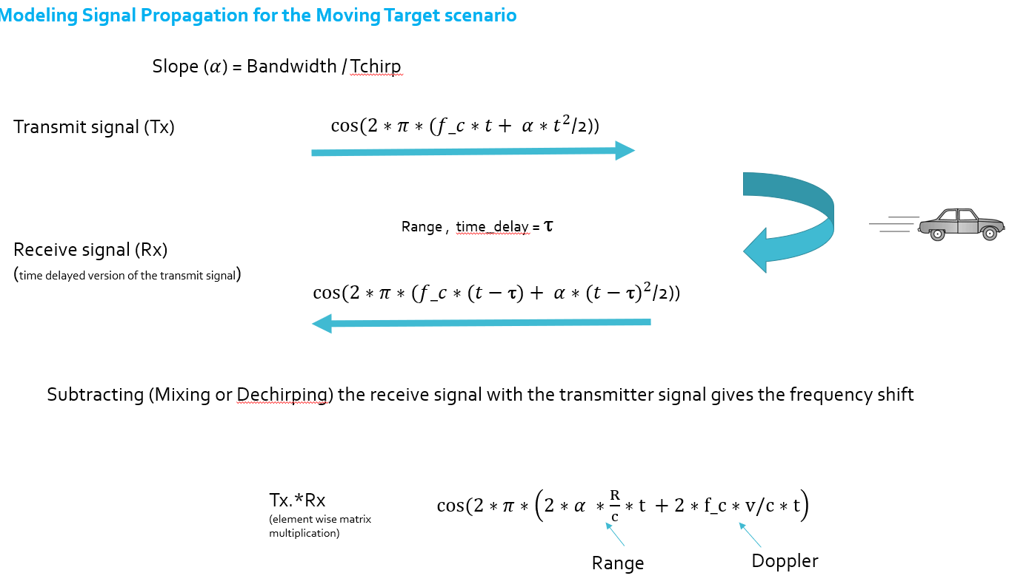

Next, you will be simulating the signal propagation and moving target scenario.

Theory : In terms of wave equation, FMCW transmit and receive signals are defined using these wave equations, where α = *Slope of the signal*. The Transmit Signal is given by:

$$T_{x}=\cos\left(2π\left(f_{c}t+ \frac{αt^{2}}{2}\right)\right)$$

The received signal is nothing but the time delayed version of the Transmit Signal. In digital signal processing the time delayed version is defined by $(t- τ)$, where $τ$ represents the delay time, which in radar processing is the trip time for the signal.

Replacing $t$ with $(t- τ)$ gives the Receive Signal:

$$R_{x}= \cos\left(2π\left(f_{c}(t-τ)+ \frac{α{(t- τ)}^{2}}{2}\right)\right)$$

On mixing these two signals, we get the beat signal, which holds the values for both range as well as doppler. By implementing the 2D FFT on this beat signal, we can extract both Range and Doppler information.

The beat signal can be calculated by multiplying the Transmit signal with Receive signal. This process in turn works as frequency subtraction. It is implemented by element by element multiplication of transmit and receive signal matrices.

$$Mixed or Beat Signal=\left(T_{x}.*R_{x}\right)$$

$$T_{x}.*R_{x}= \cos\left(2π\left(\frac{2αR}{c}t+ \frac{2f_{c}v}{c}t\right)\right)$$

**FFT Operation**

* Implement the 1D FFT on the Mixed Signal
* Reshape the vector into Nr*Nd array.
* Run the FFT on the beat signal along the range bins dimension (Nr)
* Normalize the FFT output.
* Take the absolute value of that output.
* Keep one half of the signal
* Plot the output
* There should be a peak at the initial position of the target

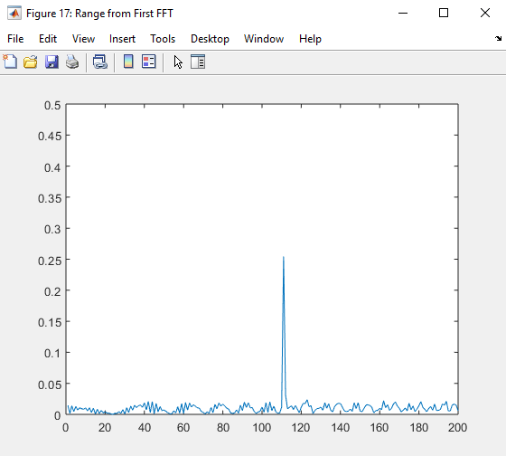

The 1st FFT output for the target located at 110 meters

The 2nd FFT is already implemented in the code. It will generate a Range Doppler Map as seen in the image below and it will be given by variable ‘RDM’. Next task is to implement the CFAR on this Range Doppler Map.

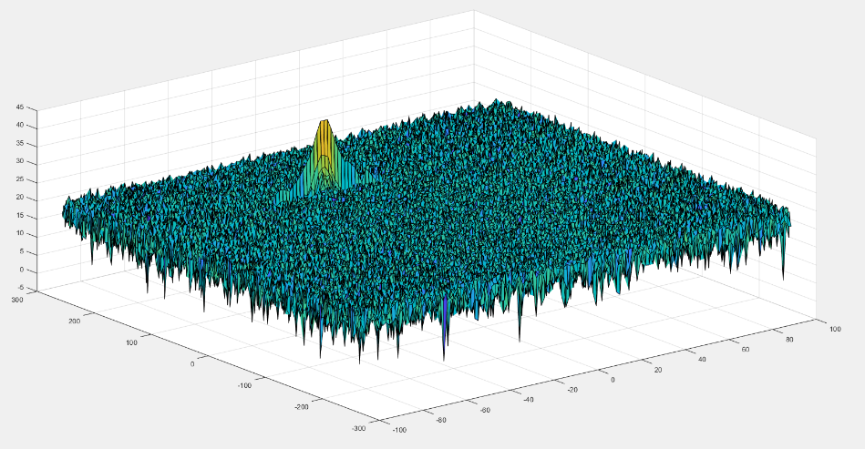

2D FFT output - Range Doppler Map

**2D CFAR**

* Determine the number of Training cells for each dimension. Similarly, pick the number of guard cells.
* Slide the cell under test across the complete matrix. Make sure the CUT has margin for Training and Guard cells from the edges.
* For every iteration sum the signal level within all the training cells. To sum convert the value from logarithmic to linear using db2pow function.
* Average the summed values for all of the training cells used. After averaging convert it back to logarithmic using pow2db.
* Further add the offset to it to determine the threshold.
* Next, compare the signal under CUT against this threshold.
* If the CUT level > threshold assign it a value of 1, else equate it to 0.

The process above will generate a thresholded block, which is smaller than the Range Doppler Map as the CUTs cannot be located at the edges of the matrix due to the presence of Target and Guard cells. Hence, those cells will not be thresholded. To keep the map size same as it was before CFAR, equate all the non-thresholded cells to 0.

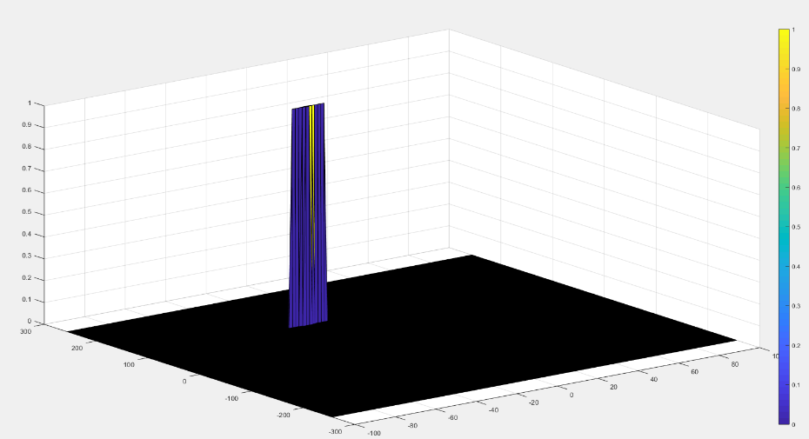

The output of the 2D CFAR process

Once you have completed this, you are done. Congratulations on doing a great job on this final project!

### 2.5.2 Placeholder

## Placeholder

# Camera

## Autonomous Vehicles and Computer Vision

### Levels of Autonomous Driving

According to CB Insights, there are 46 corporations currently working on autonomous vehicles (as of April 2019). This includes automakers such as Audi, Tesla, BMW, Volvo or GM but also new additions to the automotive space such as Alphabet / Waymo, Uber or Baidu - who hail from totally different industries.

It is expected that the autonomous vehicle market will grow from $54 billion in 2019 to $556 billion in 2026, according to Allied Market Research estimates. Such growth rates, combined with technological break-throughs of recent years, explain why things are moving so fast and why everyone is trying to get a share of this emerging market.

In addition to autonomous vehicles, there are systems which assist the driver in various driving tasks such as changing lanes, remembering speed signs or braking in time in case the preceding vehicle suddenly decelerates. Such systems are referred to as Advanced Driver Assistance Systems (ADAS) and they are the predecessor of a fully autonomous vehicle. There are some vehicles in the market, however, that imply full autonomy (such as the Tesla Autopilot), but are ‚only‘ an ADAS systems.

Before we analyze a selection of autonomous vehicle prototypes and their respective sensors, let us look at a way to define autonomy - because not all autonomous cars and driver assistance systems are created equal. The following graphic shows the „levels of autonomous driving“, which the Society of Autonomous Engineers (SAE) has defined.

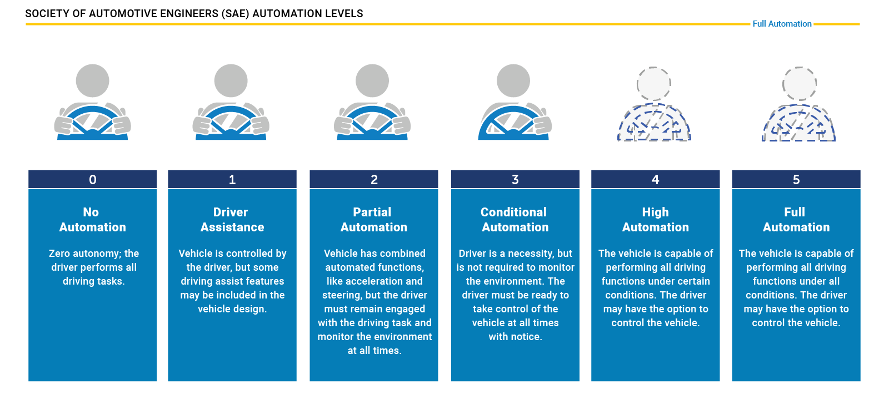

For many years, ADAS products such as forward collision warning (FCW) or adaptive cruise control (ACC) were the only systems available that provided at least some degree of automation in a selected number of driving situations (e.g. on highways, in cities at low speed).

Tesla has been one of the first companies world-wide to introduce a system into the market that promised a high degree of autonomy, the Auto Pilot. On the SAE chart however, this system is „only“ at level 2, that means the driver must remain engaged and should monitor the environment at all times.

The step to level 3 is a large one as the driver is no longer required to monitor the environment, even though he must be able to take back control at all times. From a legal viewpoint this means that the responsibility for the driving task is with the car and thus with the manufacturer. This is why we do not see a large number of commercially available vehicles with level 3 systems on board yet. Several manufacturers have announced such systems but at the time of writing (May 2019), we do not find them in the market. The reason for this is three-fold:

* Such systems must be build reliable enough to minimize the number of faulty decisions. Engineers usually solve this problem by adding a large number of sensors to the car, which makes such systems (very) costly.
* The fear of law suits arising from accidents results in an intentionally reduced availability of systems, for example by limiting the driving speed or the scenario (e.g. only in traffic jams on highways with clearly visible lane markings at speeds below 60kph).
* The readiness of the driver to take control of the vehicle can not be guaranteed at all times. There are many situations in which this is not possible due to human reaction times and alertness levels.

Therefore, many experts believe that level 3 systems will only be a transition step to more advanced systems which are operating on levels 4 and 5. At those levels, the vehicle is capable of performing all driving tasks and the „driver“ is not required to take control. Obviously, such systems will require a strong engineering effort to guarantee driver and road user safety at all times.

### Autonomous Vehicle Sensor Sets

In the last section you have learned about the different levels of autonomous driving and about the leap it takes to move from level 2 to level 3 or even further. It should now be obvious that one key to level 4 and level 5 autonomy is a smart combination of sensors and perception algorithms to monitor the vehicle environment at all times to guarantee a proper and safe reaction to all traffic events.

To give you an idea of how this problem is approached in practice, this section contains a brief overview of some vehicles that aim at realizing level 4 or even level 5 driving. As this course is mostly about cameras and computer vision and to a small degree also about Lidar, let us focus mainly on those two sensor types. Let us now take a look at a few autonomous vehicles and their respective sensor suites.

**The Uber ATG Autonomous Vehicle**

The current version of the Uber autonomous vehicle combines a top-mounted 360° Lidar scanner with several cameras and radar sensors placed around the car circumference.

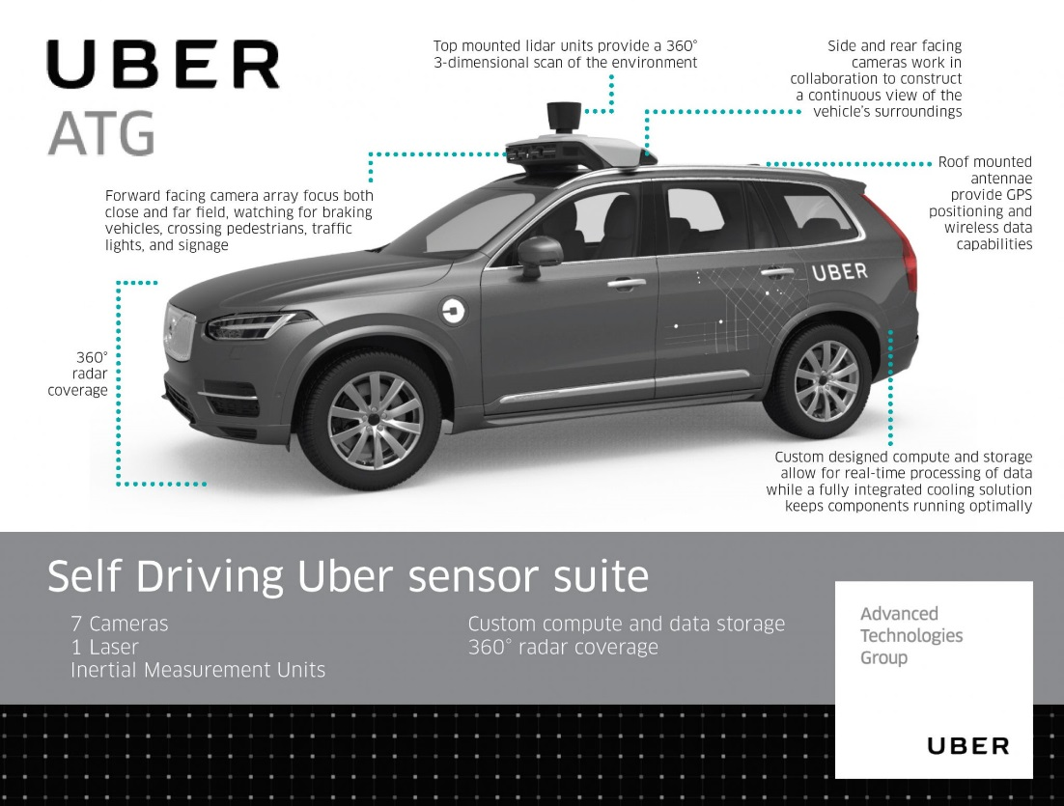

Let us take a look at those sensor classes one-by one:

* *Cameras*: Ubers fleet of modified Volvo XC90 SUVs features a range of cameras on their roofs, plus additional cameras that point to the sides and behind the car. The roof cameras are able to focus both close and far field, watch for braking vehicles, crossing pedestrians, traffic lights, and signage. The cameras feed their material to a central on-board computer, which also receives the signals of the other sensors to create a precise image of the vehicle’s surroundings. Much like human eyes, the performance of camera systems at night is strongly reduced, which makes them less reliable to locate objects with the required detection rates and positional accuracy. This is why the Uber fleet is equipped with two additional sensor types.
* *Radar*: Radar systems emit radio waves which are reflected off of (many but not all) objects. The returning waves can be analyzed with regard to their runtime (which gives distance) as well as their shifted frequency (which gives relative speed). The latter property clearly distinguished the radar from the other two sensor types as it is the only one who is able to directly measure the speed of objects. Also, radar is very robust against adverse weather conditions like heavy snow and thick fog. Used by cruise control systems for many years, radar works best when identifying larger objects with good reflective properties. When it comes to detecting smaller or „soft“ objects (humans, animals) with reduced reflective properties, the radar detection performance drops. Even though camera and radar combine well, there are situations where both sensors do not work optimally - which is why Uber chose to throw a third sensor into the mix.
* *Lidar* : Lidar works in a similar way to radar, but instead of emitting radio waves it uses infrared light. The roof-mounted sensor rotates at a high velocity and builds a detailed 3D image of its surroundings. In case of the Velodyne VLS-128, a total of 128 laser beams is used to detect obstacles up to a distance of 300 meters. During a single spin through 360 degrees, a total of up to 4 million data points per second is generated. Similar to the camera, Lidar is an optical sensor. It has the significant advantage however of "bringing its own light source“, whereas cameras are dependent on ambient light and the vehicle headlights. It has to be noted however, that Lidar performance is also reduced in adverse environmental conditions such as snow, heavy rain or fog. Coupled with low reflective properties of certain materials, a Lidar might thus fail at generating a sufficiently dense point cloud for some objects in traffic, leaving only a few 3D points with which to work. It is thus a good idea to combine Lidar with other sensors to ensure that detection performance is sufficiently high for autonomous navigation through traffic.

**Mercedes Benz Autonomous Prototype**

Currently, German car maker Mercedes Benz is developing an autonomous vehicle prototype that is equipped with cameras, Lidar and radar sensors, similar to the Uber vehicle. Mercedes uses several cameras to scan the area around the vehicle. Of special interest is a stereo setup consisting of two synchronized cameras, which is able to measure depth by finding corresponding features in both images. The picture below shows the entire host of cameras used by the system. Mercedes states that the stereo camera alone generates a total of 100 gigabytes of data for every kilometer driven.

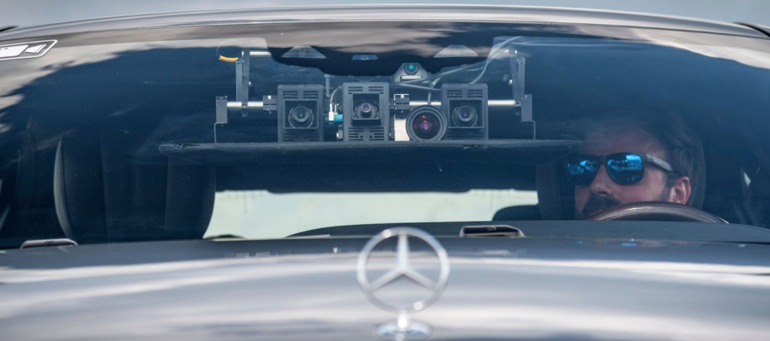

**The Tesla Autopilot**

When the Autopilot system was first sold, it basically was a combination of adaptive cruise control and lane change assist - a set of functions which had long been available with other manufacturers around the globe. The name „Autopilot“ implied however, that the car would be truly autonomous. And indeed did many Tesla owners test the system to its limits by climbing onto the back seat , reading a book or taking a nap while being driven by the system. On the SAE scale however, the Autopilot can „only“ be classified as level 2, i.e. the driver is responsible for the driving task at all times.

In October 2016, the Tesla Model S and X sensor set was significantly upgraded and the capabilities of the Autopilot were extended by regular airborne software updates.

The image shows the interior of a Tesla with the camera views superimposed on the right side. The image shows left and right rear-facing cameras as well as a forward-facing camera for medium-range perception.

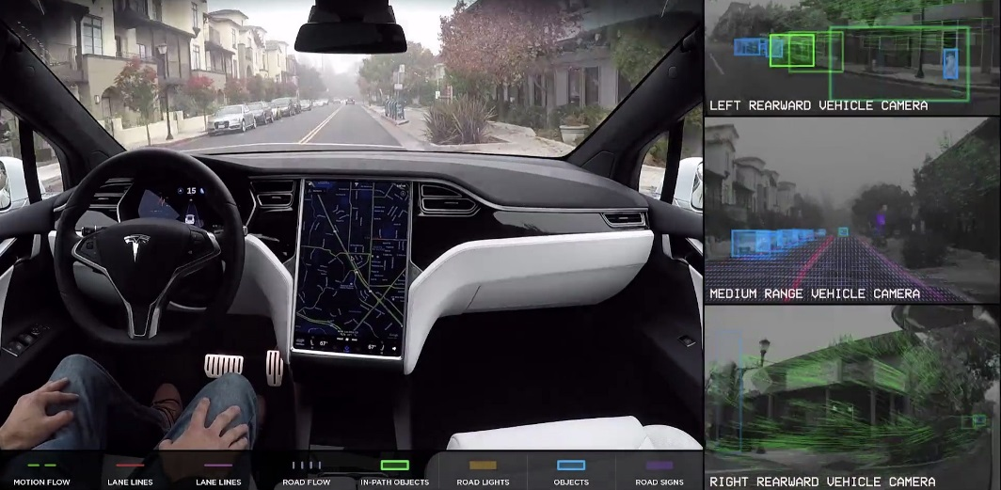

As can be seen in the overview, the system combines several camera sensors with partially overlapping fields of view with a forward-facing radar sensor.

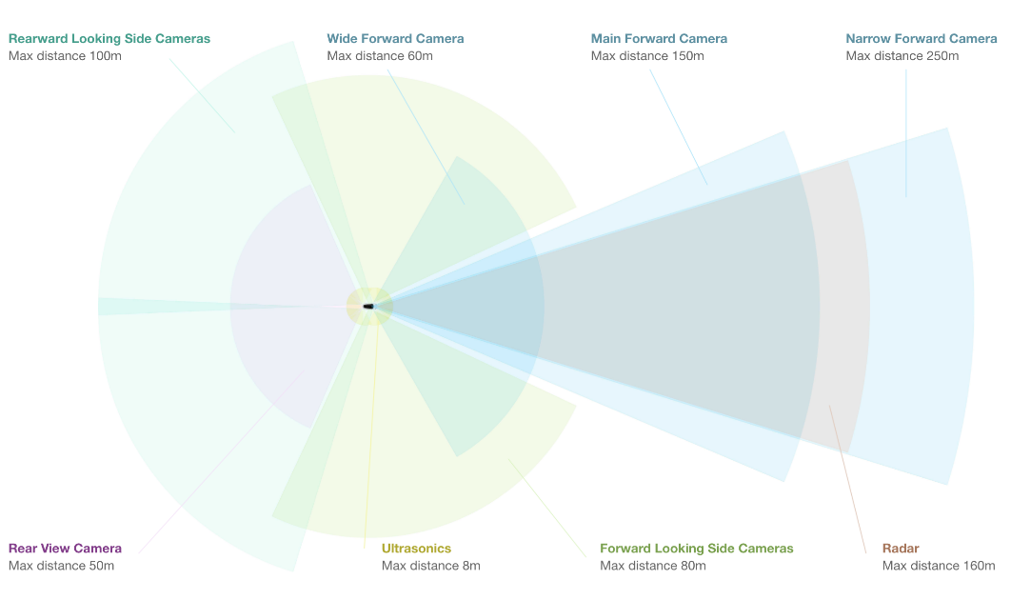

Let us look at each sensor type in turn:

* *Cameras* : The forward-facing optical array consists of four cameras with differing focal lengths. The narrow-forward camera captures footage up until 250m in front, the forward camera with a slightly larger opening angle looks up until 150m in front, a wide-angle camera that captures 60m in front, and a set of forward-looking side cameras that capture footage 80m in front and to the side of the car. The wide-angle camera is designed to read road signs and traffic lights, allowing the car to react accordingly. It is debated however, whether this feature can be reliably used in traffic.
* *Radar* : The forward-looking radar can see up to 160m ahead of the car. According to Tesla founder Elon Musk it is able to see through "sand, snow, fog—almost anything".
* *Sonar* : A 360° ultrasonic sonar detects obstacles in an eight-meter radius around the car. The ultrasonic sensors work at any speed and are used to spot objects in close proximity of the car. The ultrasonic sensors can also be used to assist the car when automatically switching lanes. Their range however, compared to the other sensors of the set, is significantly limited and ends at about 8 meters distance.

As you may have noticed, Tesla is not using a Lidar sensor despite its plans to offer level 4 or even level 5 autonomous driving with this setup. Unlike many other manufacturers who aim at full autonomy such as Uber, Waymo and several others, Tesla is convinced that a set of high-performance cameras coupled with a powerful radar sensor will be sufficient for level 4 / level 5 autonomy. At the time of writing, there is a fierce debate going on about the best sensor set of autonomous vehicles. Tesla argues that the price and packaging disadvantage of Lidar would make the Autopilot unattractive to customers. Harsh critics such as GM's director of autonomous vehicle integration Scott Miller disagrees and argues with the highly elevated safety requirements of autonomous vehicles, which would not be met with cameras and radar alone.

Is has to be noted however that in all sensor setups, be it Uber, Tesla, Waymo or traditional manufacturers such as Mercedes or Audi, cameras are always used. Even though there is an ongoing debate on wether radar or Lidar or a combination of the two would be best, cameras are never in question. It is therefore a good idea to learn about cameras and computer vision, which we will do in great detail in this course.

**Sensor Selection Criteria**

The design of an autonomous or ADAS-equipped vehicle involves the selection of a suitable sensor set. As you have learned in the preceding section, there is a discussion going on about which combination of sensors would be necessary to reach full (or even partial) autonomy. In this section, you will learn about sensor selection criteria as well as the differences between camera, Lidar and radar with respect to each criterion.

In the following, the most typical selection criteria are briefly discussed.

1. **Range** : Lidar and radar systems can detect objects at distances ranging from a few meters to more than 200m. Many Lidar systems have difficulties detecting objects at very close distances, whereas radar can detect objects from less than a meter, depending on the system type (either long, mid or short range) . Mono cameras are not able to reliably measure metric distance to object - this is only possible by making some assumptions about the nature of the world (e.g. planar road surface). Stereo cameras on the other hand can measure distance, but only up to a distance of approx. 80m with accuracy deteriorating significantly from there.
2. **Spatial** **resolution** : Lidar scans have a spatial resolution in the order of 0.1° due to the short wavelength of the emitted IR laser light . This allows for high-resolution 3D scans and thus characterization of objects in a scene. Radar on the other hand can not resolve small features very well, especially as distances increase. The spatial resolution of camera systems is defined by the optics, by the pixel size on the image and by its signal-to-noise ratio. Details on small object are lost as soon as the light rays emanating from them are spread to several pixels on the image sensor (blurring). Also, when little ambient light exists to illuminate objects, spatial resolution increases as objects details are superimposed by increasing noise levels of the imager.
3. **Robustness** **in** **darkness** : Both radar and Lidar have an excellent robustness in darkness, as they are both active sensors. While daytime performance of Lidar systems is very good, they have an even better performance at night because there is no ambient sunlight that might interfere with the detection of IR laser reflections. Cameras on the other hand have a very reduced detection capability at night, as they are passive sensors that rely on ambient light. Even though there have been advances in night time performance of image sensors, they have the lowest performance among the three sensor types.
4. **Robustness** **in** **rain,** **snow,** **fog** : One of the biggest benefits of radar sensors is their performance under adverse weather conditions. They are not significantly affected by snow, heavy rain or any other obstruction in the air such as fog or sand particles. As an optical system, Lidar and camera are susceptible to adverse weather and its performance usually degrades significantly with increasing levels of adversity.
5. **Classification** **of** **objects** : Cameras excel at classifying objects such as vehicles, pedestrians, speed signs and many others. This is one of the prime advantage of camera systems and recent advances in AI emphasize this even stronger. Lidar scans with their high-density 3D point clouds also allow for a certain level of classification, albeit with less object diversity than cameras. Radar systems do not allow for much object classification.
6. **Perceiving** **2D** **structures** : Camera systems are the only sensor able to interpret two-dimensional information such as speed signs, lane markings or traffic lights, as they are able to measure both color and light intensity. This is the primary advantage of cameras over the other sensor types.
7. **Measure** **speed** : Radar can directly measure the velocity of objects by exploiting the Doppler frequency shift. This is one of the primary advantages of radar sensors. Lidar can only approximate speed by using successive distance measurements, which makes it less accurate in this regard. Cameras, even though they are not able to measure distance, can measure time to collision by observing the displacement of objects on the image plane. This property will be used later in this course.
8. **System** **cost** : Radar systems have been widely used in the automotive industry in recent years with current systems being highly compact and affordable. The same holds for mono cameras, which have a price well below US$100 in most cases. Stereo cameras are more expensive due to the increased hardware cost and the significantly lower number of units in the market. Lidar has gained popularity over the last years, especially in the automotive industry. Due to technological advances, its cost has dropped from more than US$75,000 to below US$5,000. Many experts predict that the cost of a Lidar module might drop to less than US$500 over the next years.
9. **Package** **size** : Both radar and mono cameras can be integrated very well into vehicles. Stereo cameras are in some cases bulky, which makes it harder to integrate them behind the windshield as they sometimes may restrict the driver's field of vision. Lidar systems exist in various sizes. The 360° scanning Lidar is typically mounted on top of the roof and is thus very well visible. The industry shift towards much smaller solid-state Lidar systems will dramatically shrink the system size of Lidar sensors in the very near future.
10. **Computational** **requirements** : Lidar and radar require little back-end processing. While cameras are a cost-efficient and easily available sensor, they require significant processing to extract useful information from the images, which adds to the overall system cost.

### Camera Technology Overview

In this section you will learn about the basic properties of a camera. We will start from the most basic model called a „pinhole camera“ and then progress to using lenses, which are a key component of camera systems. You need this knowledge in order to understand how a camera creates images, which of its properties influence image appearance and quality and which parameters you have to consider in order to successfully extract meaningful information from these images.

**The Pinhole Camera**

A very simple camera can be designed by placing a light barrier with a tiny opening (the pinhole) between an object of interest. The light emitted by the object passes through the pinhole and lands on a photosensitive surface which stores the light information as an image. The reason why the pinhole has been made so small is to avoid image blurring due to superimposing rays of light stemming from various parts of the object of interest.

This simple principle has been well known for centuries and was for example used by artists to create photorealistic portraits.

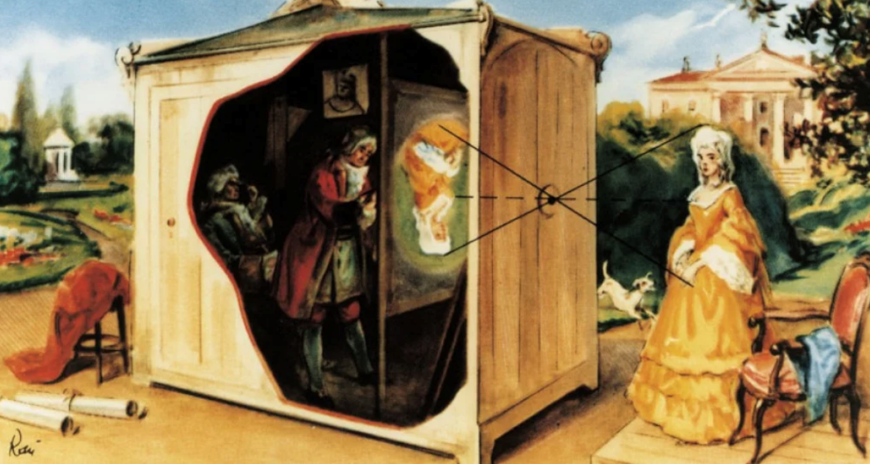

A formal model of the pinhole camera model is shown below:

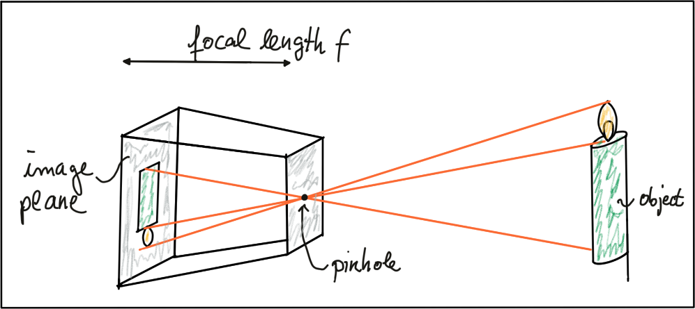

The photosensitive surface on the left is called the *image plane* whereas the pinhole is called the *camera center*. The distance between the camera center and the image plane is called the *focal length f*.

A point P on the object of interest can be mapped to a point P’ on the image plane by casting a beam through the center of projection until it hits the image plane as shown in the figure below.

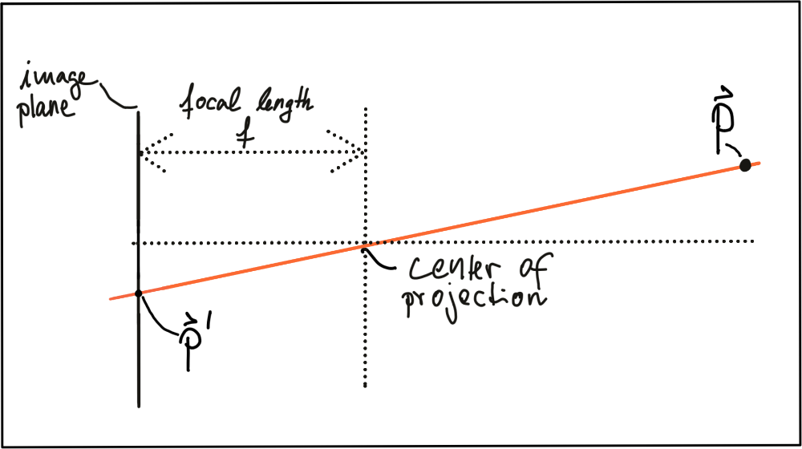

In three-dimensional space, the relation between $P$ and $P^{'}$ is expressed by the following equations:

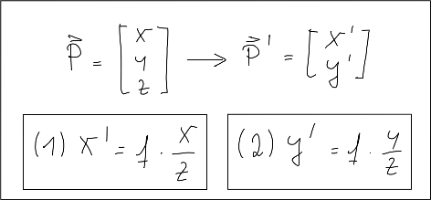

Based on these equations, we are able to compute the 2D position of an object on the image plane, given the 3D position of the object in space as well as the focal length of the camera. Note however that the resulting coordinates x’ and y’ are metrical coordinates and not pixel positions yet.

The problem with pinhole cameras is that the amount of light passing through the pinhole is not sufficient to generate a decent image on an image sensor. If one were to increase the amount of light by widening the pinhole opening as shown in the figure below, rays of light from other parts of the object of interest would superimpose each other, leading to a blurring effect: The larger the pinhole, the brighter the image but at the same time, the more severe the blurring of the object on the image plane would be.

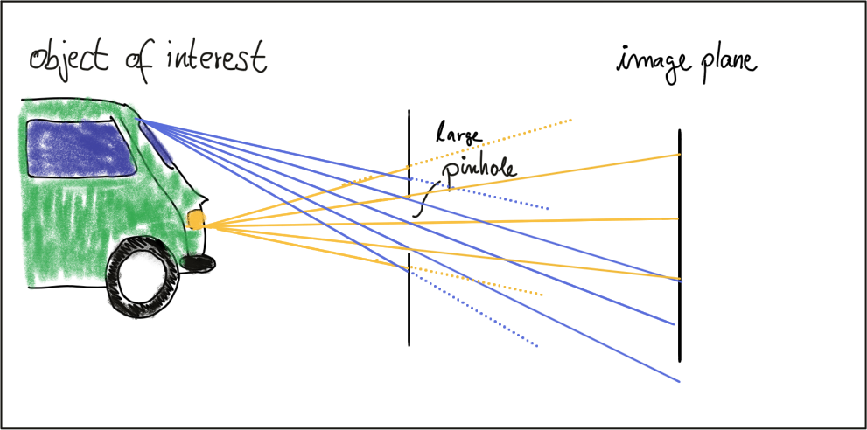

One way to solve this problem is use a lens, which is able to capture multiple rays of light that emanate from the same point on the object of interest. So let’s look at lenses next.

**Lenses and Apertures**

### Camera Technology at MBRDNA

### 3.1.5 The OpenCV Computer Vision Library

## Engineering a Collision Detection System

### Heading 1

### 3.2.2 Placeholder

## Tracking Image Features

### Heading 1

### 3.3.2 Placeholder

## Camera Based 2D Feature Tracking

### Heading 1

### 3.4.2 Placeholder

## Combing Camera and Lidar

### Heading 1

### 3.5.2 Placeholder

## Track an Object in 3D Space

### Heading 1

### 3.5.2 Placeholder

## 3.7 Placeholder

### 

### 

<https://classroom.udacity.com/nanodegrees/nd313-beta/parts/45d2275b-5183-4d45-84d9-50d113be93cb/modules/b52e21b1-f7ef-434a-9378-58b75dfa6800/lessons/7fb8e8ec-0246-4e1e-9d12-e3cdf11391b7/concepts/38df3cda-6708-40e8-b9e0-347d02339007>